**Ex. No.: 10** Date: 26/04/2022

**Problem statement:**

Create an app for a museum that captures the museum labels using the phone camera and

converts the contents into speech.

The label may contain text and longitude and latitude. The app should recognise the text and

location details and provide a speech output

**Design: (Block diagram)**

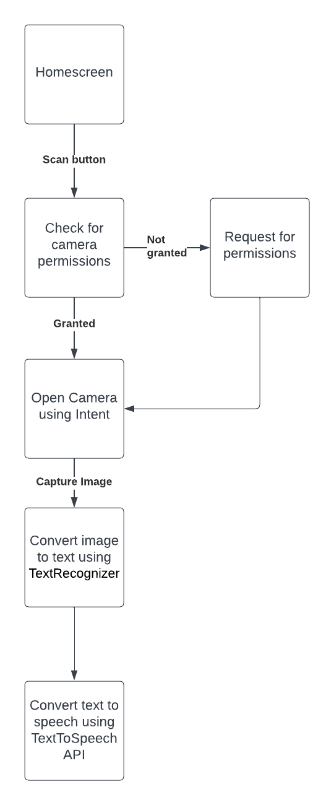

**Tool used:**

* Android Studio
* Java
* XML
* Camera API
* TextRecognizer API(Google vision)
* TextToSpeech API

**Code:** <https://drive.google.com/drive/folders/1ME77shM_DDcIjw4YwQmUA8fqM3wJIG_d?usp=sharing>

**Screenshots of application:**

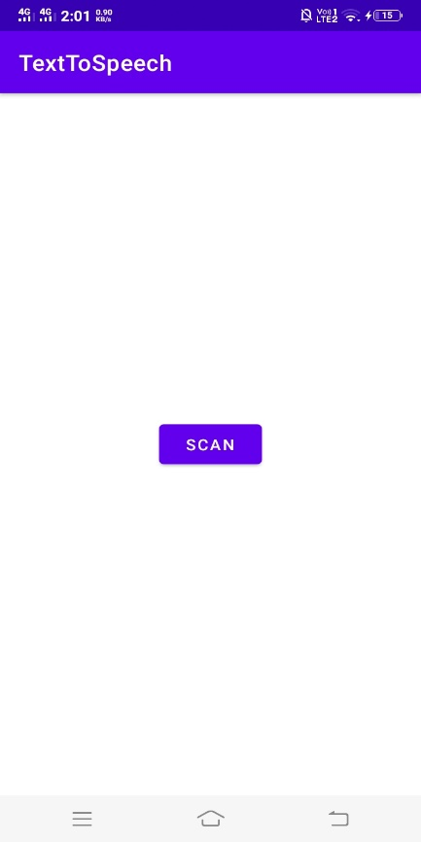

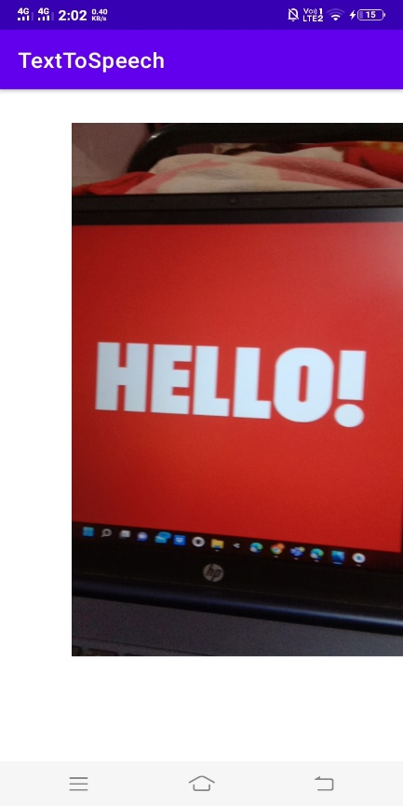 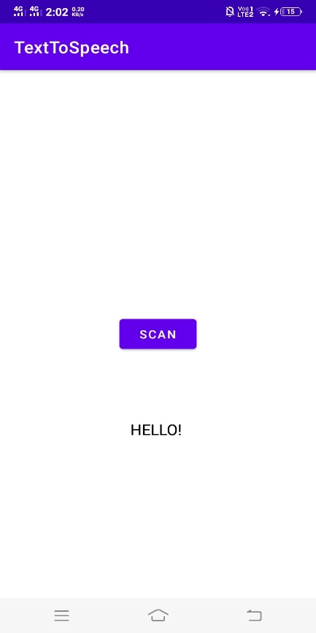

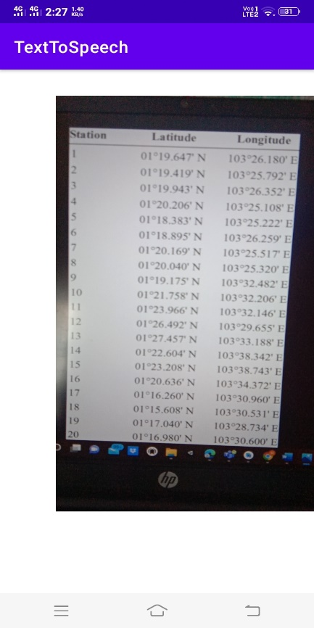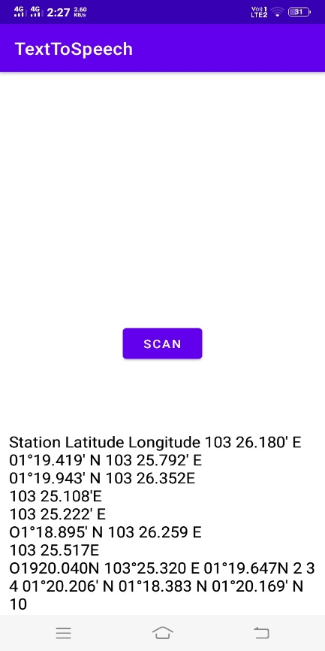

The text displayed was also being read out aloud with the help of TextToSpeech API which was shown during the demo